How does the classification of luminaires help you as the lighting designer or specifier?
By understanding different classification systems for lights, I can, as a designer, better communicate my design intent to the people I am working with in a clear and effective manner, regardless of the methods they use to classify lights.

Although the CIE System applies mostly to indoor luminaires, can you think of outdoor luminaires that produce those distribution types? Provide visual examples of at least three types of outdoor luminaires that produce light in the proportions determined by the CIE System.
Road way pole lights are direct lighting
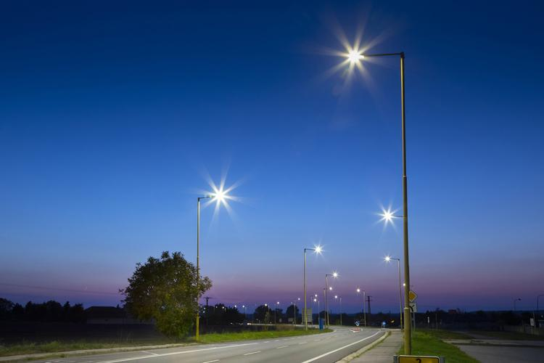

An exterior sconce that is direct-indirect
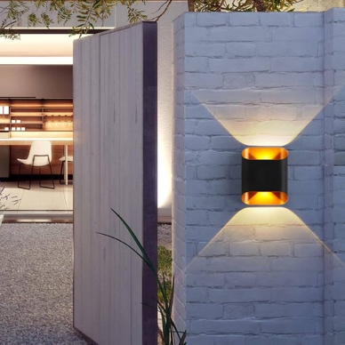

Ingrade uplight is indirect light (by definition)
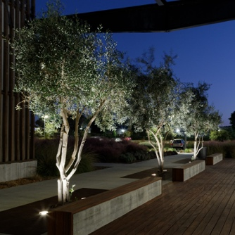

Explain your understanding of Figure 8.3
Figure 8.3 depicts the 7 different beam styles from 1 to 7 of sports luminaires. It classifies them using their field angles and projection distance with 1 being the narrowest beam and farthest throw and 7 being the widest beam angle and shortest throw.

The IES Distribution Classification is based on shape of the area that is primarily illuminated. What are those shapes?
They are primary different styles of ovals, a circle, and rounded square shape.

The Solid Angles classification system determines what three zones?
The backward solid angle extents, forward angle extents, and upward solid angle extents.

What types of outdoor luminaires are available to you, the lighting designer/engineer? Provide a sentence or two about each of these with information that is new, interesting or important to you.
Street and road
Street and roadway lighting focus on uniformity across a wide angle of light distribution and can be classified into 6 different shape types. They often don’t have large optic components due to the LEDs somewhat narrow directionality, which was cool to learn.

Pathway
Pathway lighting is often a much smaller scale, bollards that are a few feet tall or short post tops, used to illuminate pathways for pedestrian use. The goal of these lights is to illuminate the immediate vicinity for pedestrian use.

Parking lot and garage
Parking lot luminaires are often flat bottom lenses that are arranged in sets of one, two or four and used to illuminate large flat areas. In parking structures, wall mounted lights are often used instead of ceiling mounted lights which would reduce clearance levels. These wall mounted lights have a bilateral distribution that throw light away from the wall.

Sports lighting
Sports lighting are used in a variety of locations and situations, meaning there are many different styles that can be chosen. From very narrow distributions capable of throwing light from very high above the field to wide distributions capable of lightning interior spaces from the walls of the space.

Floodlighting
Much like sports lighting, floodlighting can be used in many applications and there are many styles of floodlighting distributions and intensities. They are often not symmetrical in their distribution, allowing them to be aimed at targets more easily.

Emergency and Exit
Emergency fixtures run on battery that are charged during normal operation, and they operate when the power is cut. Exit fixtures help direct users to exits with signage or words to paths of egress and are also often battery operated as well.

Security
Security luminaires help aid in the security monitoring of an area by providing enough illuminance for surveillance.

Landscape
Landscape luminaires are used in any application to light plants, water, buildings, or other external features required to be lit. They come in a variety of different styles ranging from in grades to pole tops.

Special Application
Any specialty light built for specific scenarios like OR/patient bed lights.

Custom Luminaires
Any light that doesn’t exist and is custom built for a scenario or application.

